Install Git on windows

* To check if git is already installed on

Git –version

If not found , you will get the message git is not recognized as external command

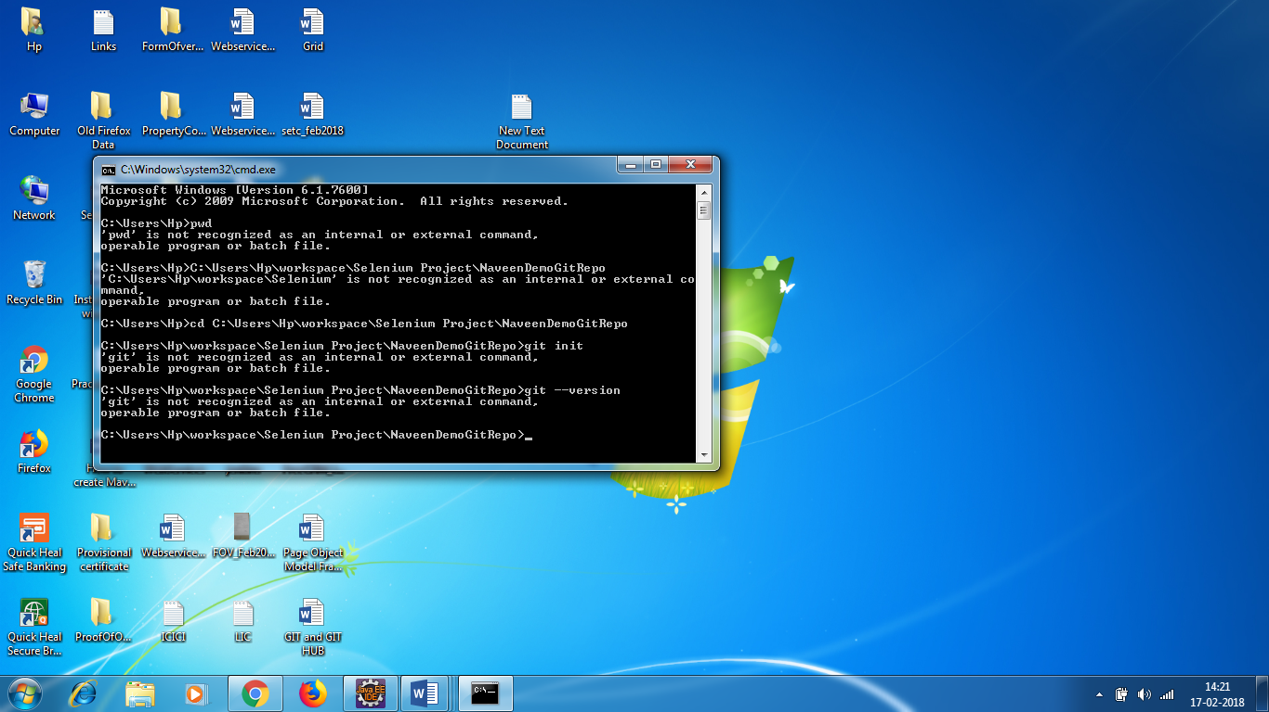

* Install git on windows

Type git on google

Go to link <https://git-scm.com/>

Click on download link

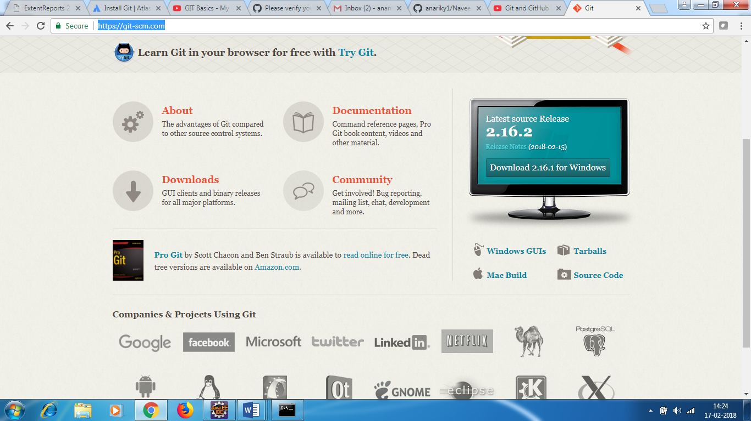

Exe file will be downloaded

Select 2nd option – use git from windows command prompt

Rest keep all as default and install

Open git bash from start menu

**Git commands**

**Command 1 :**

* Git –version
* Pwd – to check your current path

**Command 2 :**

**To initialize git**

* Go to project path folder
* Cd C:\Users\Hp\workspace\Selenium Project\NaveenDemoGitRepo
* Git init

This will start track your project – what files are being changed.

* ls –alt – will give all the all files and folder of that directory

This wil show .git file got created.

The files with .* are hidden files

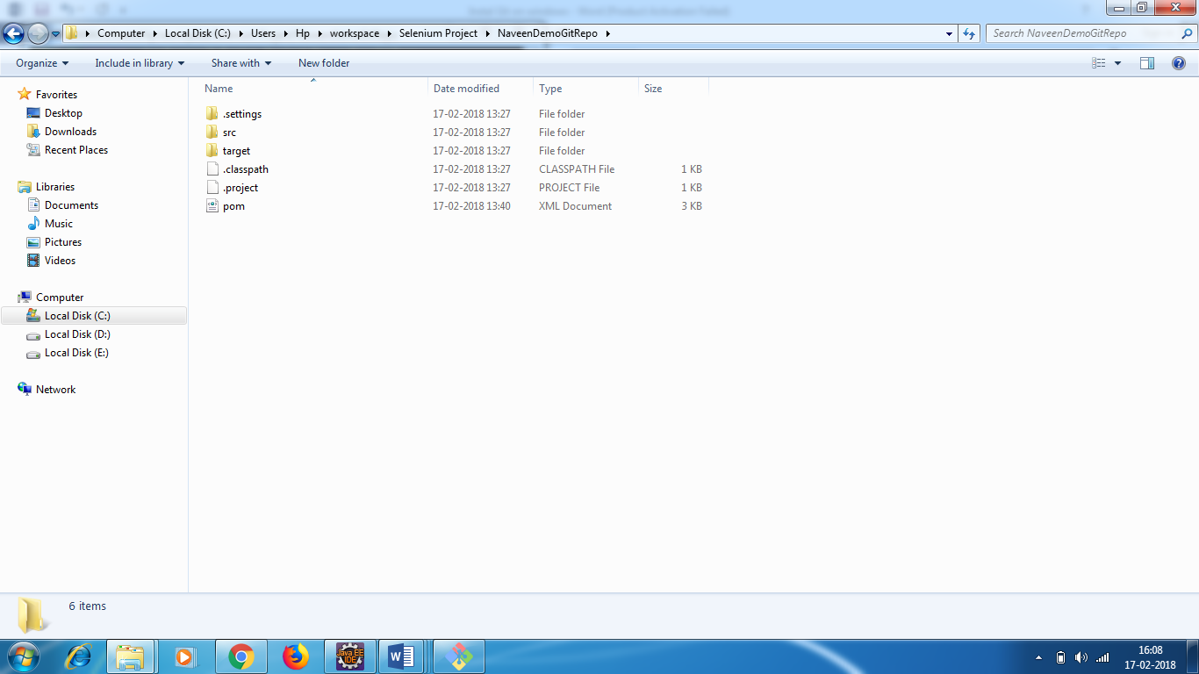

**Command 3 :**

You need to copy the git repo url and paste it in git bash . So , the project will be registered with this particular repository

Below command in git bash – don’t use cd

git remote add origin https://github.com/anariky1/NaveenDemoRepo.git

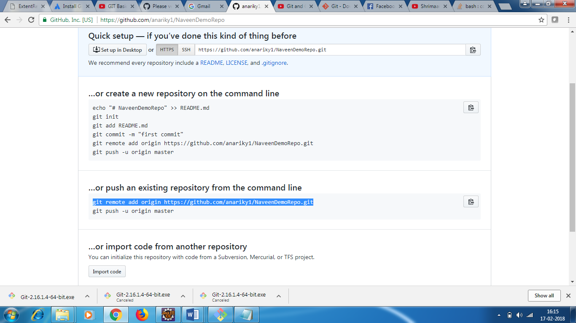

**Command 4 :**

* You need to see the current status of your project
* git status

**It will show the complete folder and files that need to be added to git git hub repo**

**You can see the folder and command in the screenshot**

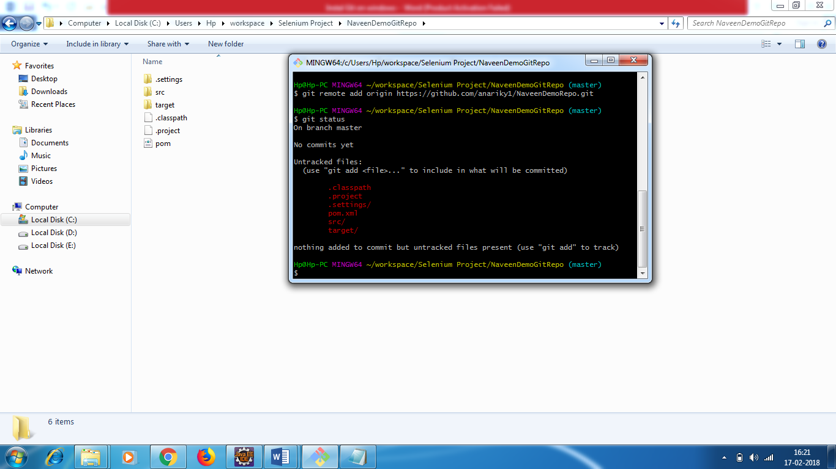

**Command 5**

* > you need to add the files showing in red color

git add . will add the complete project directory

now again do git status - what all added will be shown in green color .

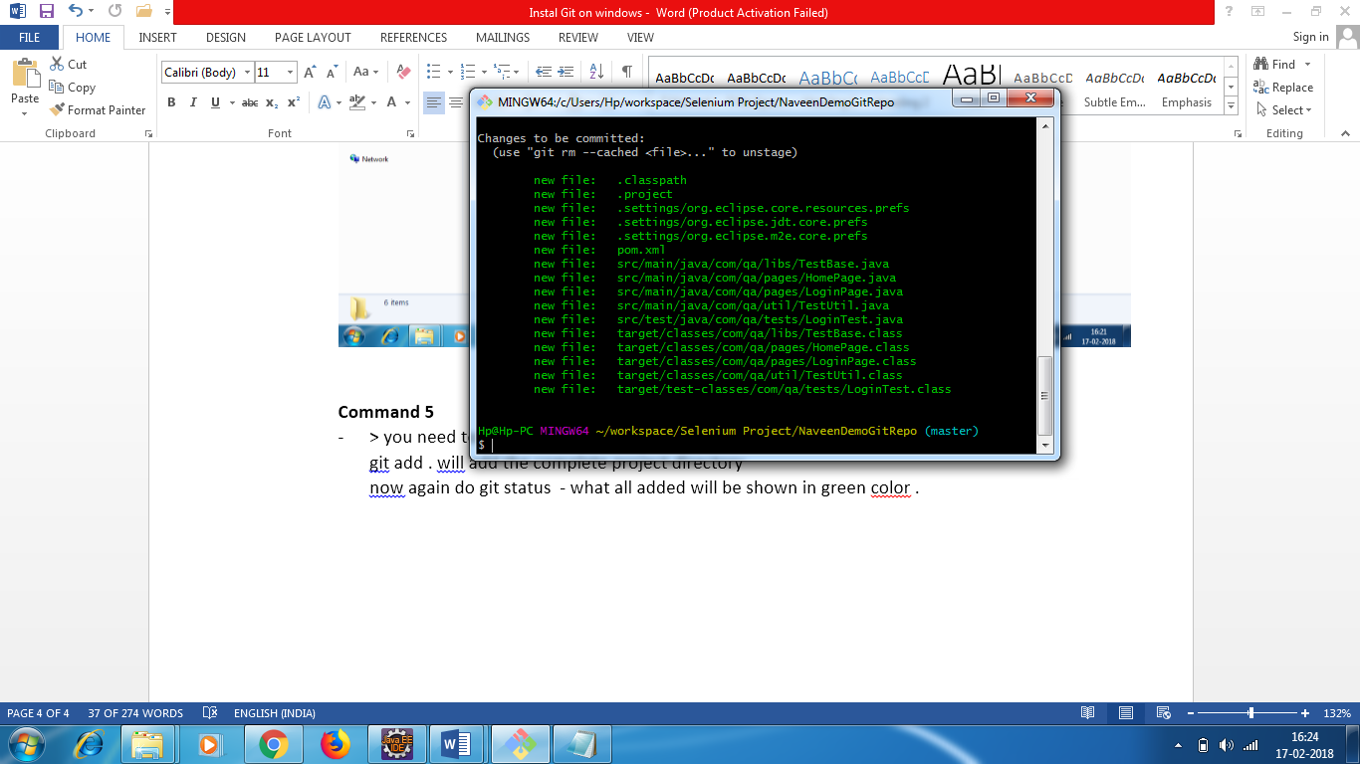

**Command 6**

* Git commit

You need to commit before pushing the changes

Git commit –m “ first git commit for my selenium code”

git config --global user.email [you@example.com](mailto:you@example.com)

git config --global user.name "Your Name"

ananthgithub@gmail.com

Handgreat99

Username : anariky1

It will some asks for user name and password

Then give the commit command

It will says files changed

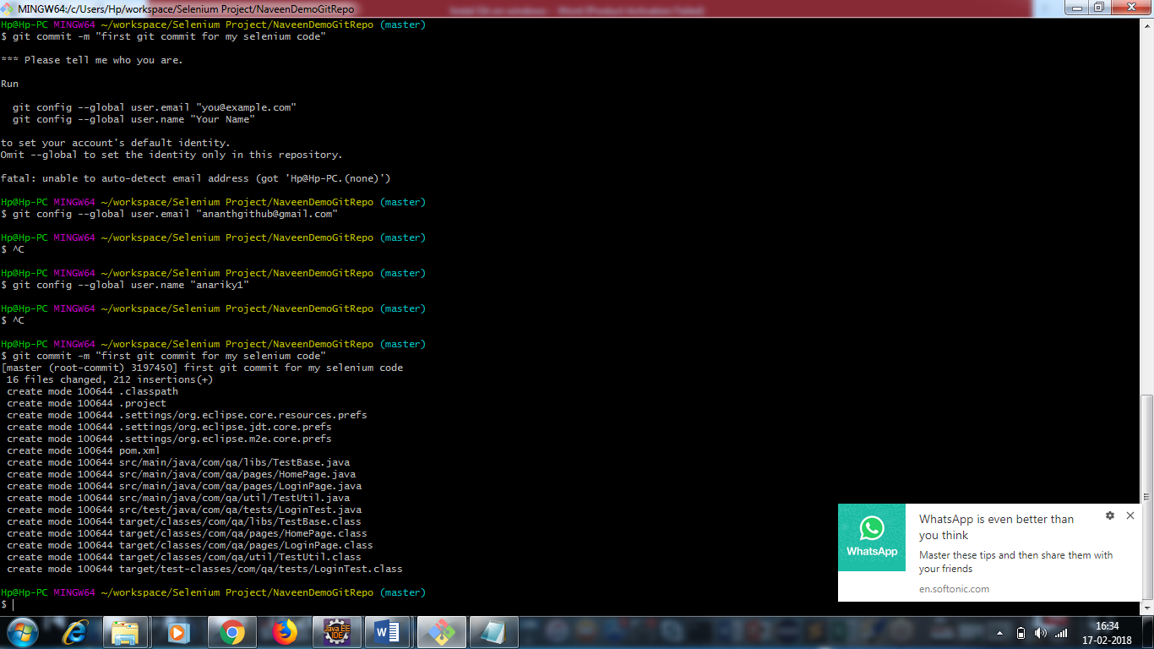

* By default one master branch will be created in git repo

**Command 7**

Git push origin master

It will not allow you to push the code.

Enter your username and password.

If you don’t have permission , you will get permission denied error.

There is a ssh concept

Ssh key should be registered in git hub – **PUSH – in order to push.**

* Go to account settings
* Click on SSH and GPG Keys
* We need to add SSH key of the people who can push the code.

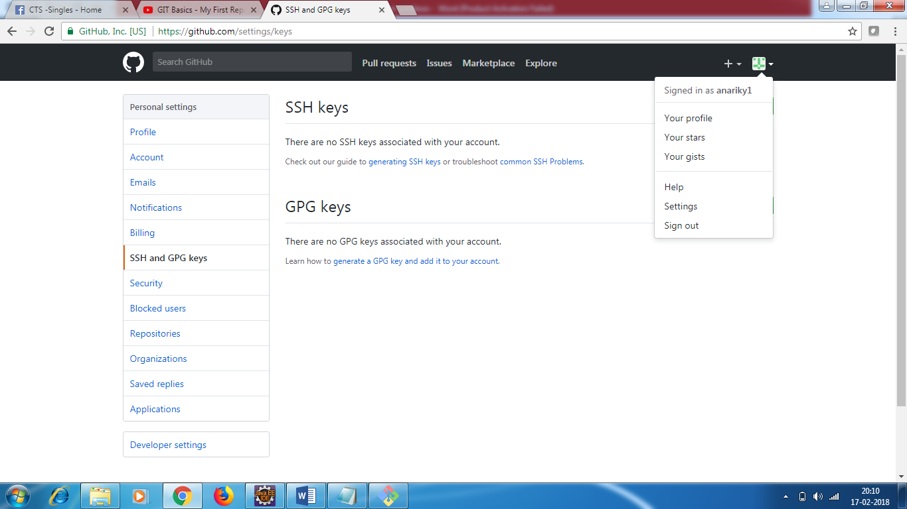

* **Click on New SSH key**

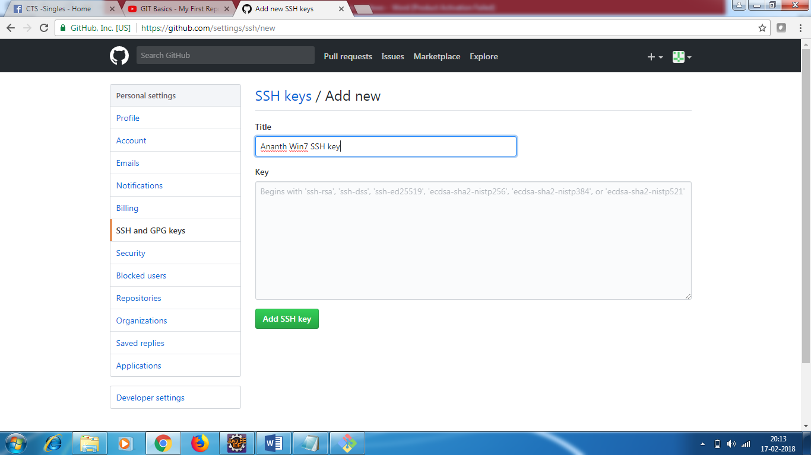

* **Enter Title as Ananth Win7 SSH Key**

**To generate SSH key ,follow the below steps**

<https://docs.joyent.com/public-cloud/getting-started/ssh-keys/generating-an-ssh-key-manually/manually-generating-your-ssh-key-in-windows>

You need to install putty and follow the steps

E 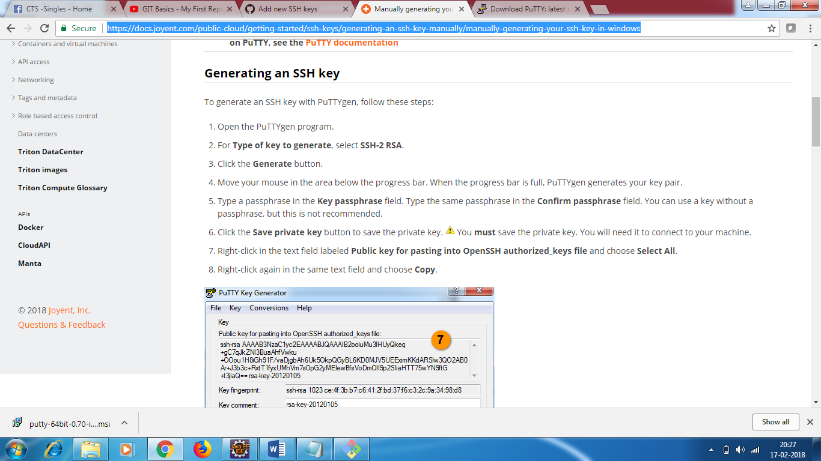

(We will see how to generate SSH keys later)

Coming back to commands git bash

* I create a new page searchpage

Git status

It will say

Modified: src/main/java/com/qa/pages/SearchPage.java

Now I add a method in existing login page class :

Git status

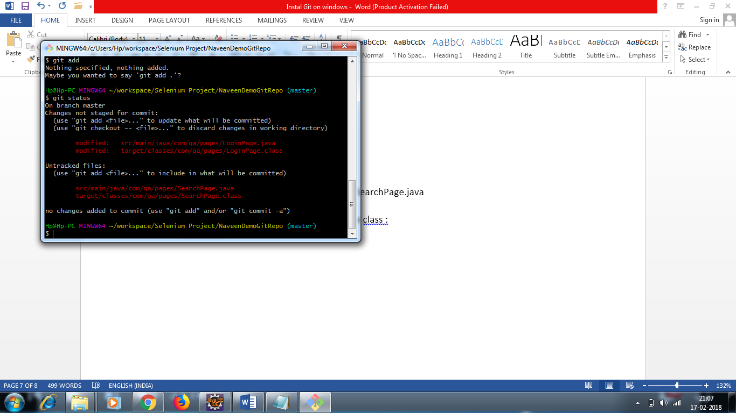

Now do git add

Now do git status

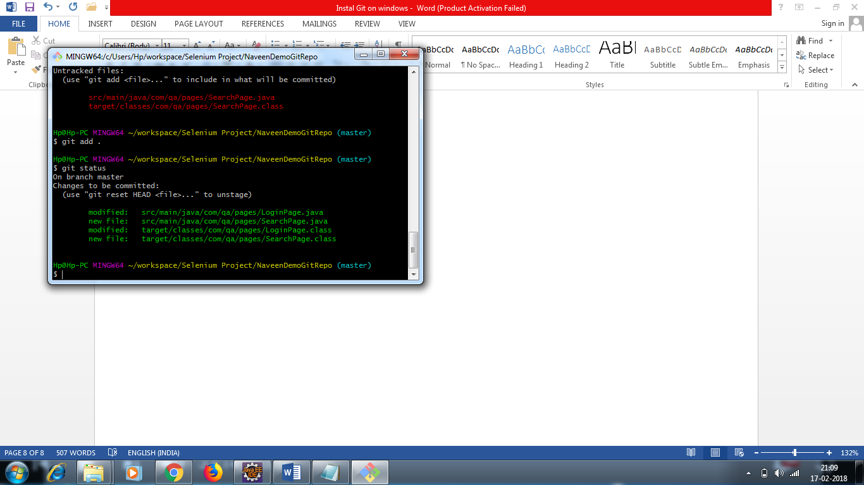

* Git commit “ added search page feature code and modified login page”
* Git push origin master.

How to pull the code

Where exactly you want to pull your code

* Go to E drive
* Create a directory NaveenDemoRepo mkdir NaveenDemoRepo
* Git clone (pulling the code)

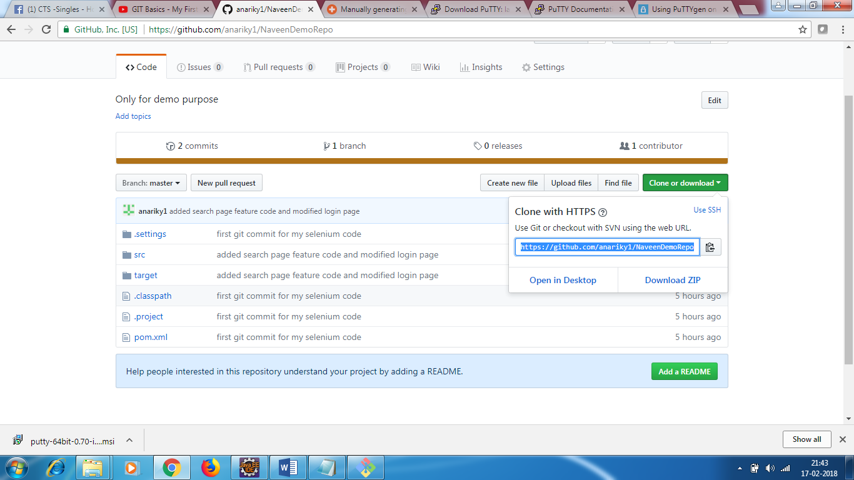

**Command 1**

**Copy the url**

**Git clone** [**https://github.com/anariky1/NaveenDemoRepo.git**](https://github.com/anariky1/NaveenDemoRepo.git)

**Cloning into NaveenDemoRepo**

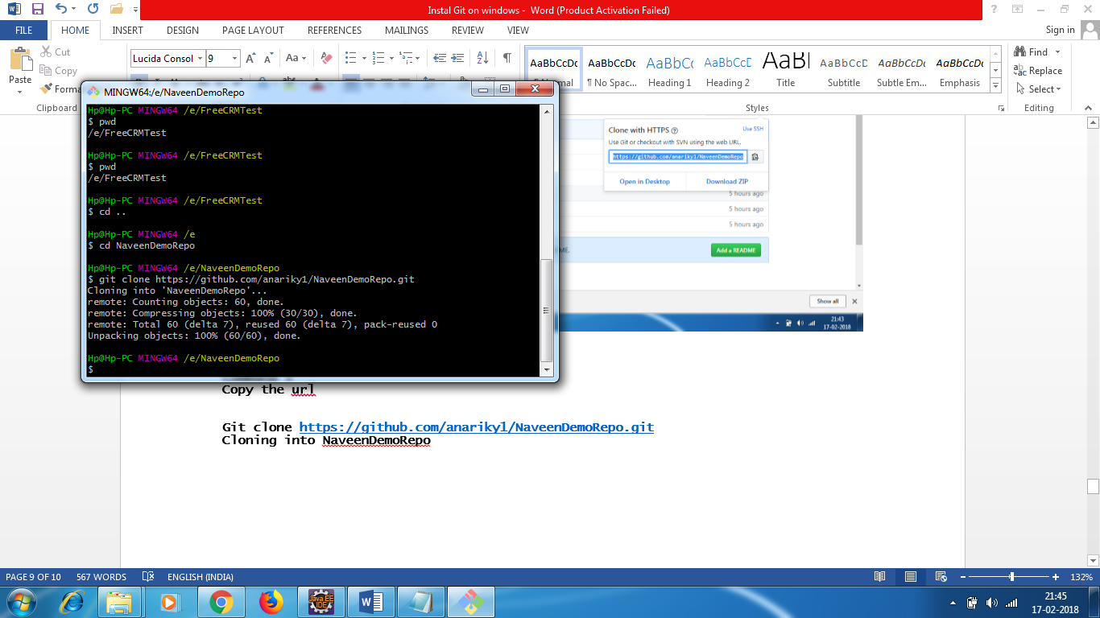

**Once cloned you will see 100% complete**

* **The code will be available in E:\**NaveenDemoRepo
* **After cloning , goto eclipse and import the project**

**How to push your code – Recap**

**1 . Create a git repo -** https://github.com/anariky1/FreeCRM-PageObjectModelFramework.git

**2. go to project directory in eclipse**

C:\Users\Hp\workspace\Selenium Project\FreeCRMTest

3 . git init

4.